Sending WebSMART Transcripts via eTranscriptCA
Viewing Transcripts sent Electronically in SHARQTC

- Student Enters request on WebSMART including the following information:

- Student Information: GID, Name, address etc. (mostly implicitly by logging in)
- Sending College
- Receiving Institution

- Sent Electronically The information included in item 1 above creates a record in Banner – Form SHARQTC:

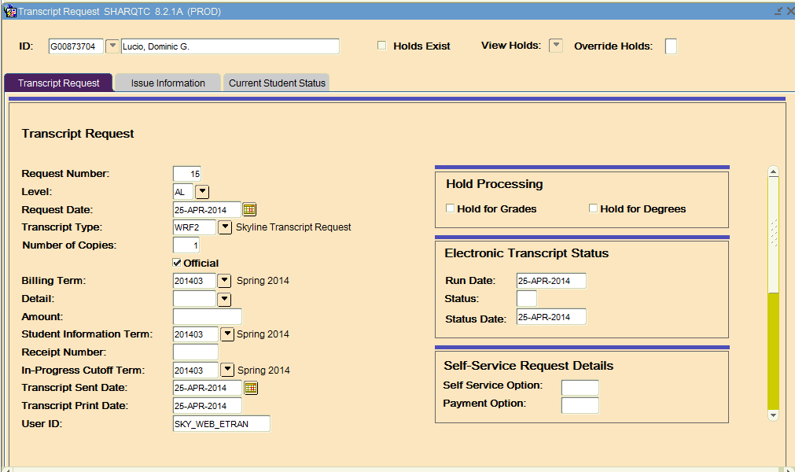

- SHARQTC Data: Here are the datapoints that indicate that the record came from a student request on the web and sent electronically:
- Transcript type: WRF2- Skyline, WRF3 – Canada, WRF4 – CSM
- Transcript sent date and print date will be the same, i.e. today’s date if the request was entered between 8:00 and 5:00. If request entered after 5:00pm, both dates will be the next working day.
- Electronic Transcript Status will be populated with the run date and the status date.

- Not Sent Electronically If the receiving institution is not an eTranscriptCA school, the request will remain on SHARQTC with the print date not populated and the Electronic Transcript Status dates not populated. Therefore, when A&R office at CSM processes transcripts, it will be included as a request that has not yet been fullfilled.

Using SHARQTC to submit eTranscript requests:
  - Submit SHARQTC record with a transcript type code of WRF2, WRF3, or WRF4 in
  - The transcript destination code on the ‘Issue Information’ tab of SHARQTC must be for an eTranscriptCA school.
  - Here is an example:
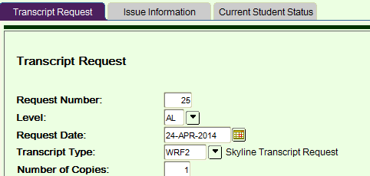

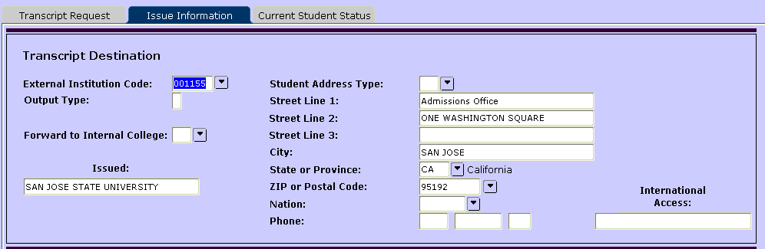

You will know that your transcript was delivered electronicallly if you see the dates populated on the right hand side of the first screen ‘Electronic Transcript Status’ as seen below:
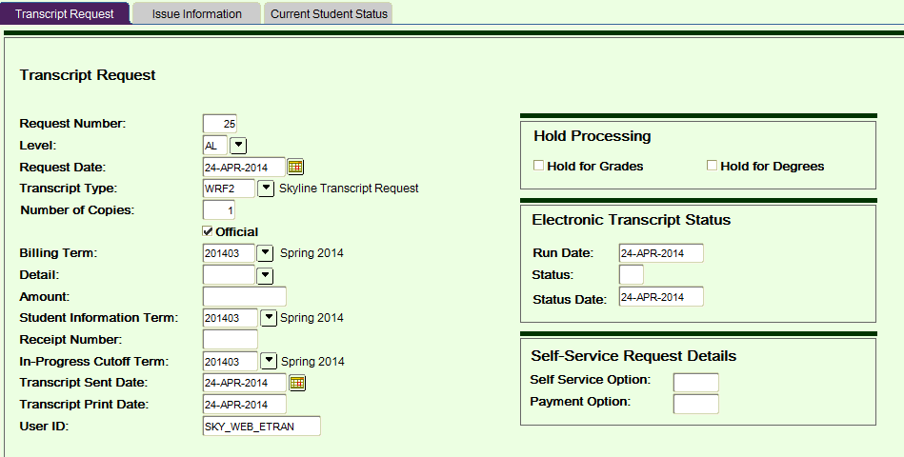

The transcript generated will be an ‘unsolicited’ transcript on the XAP website:
